**Index**

1. **Abstract**
2. **User Requirement**
3. **Screens**
4. **Project Structure**
5. **Note**
6. **Future Development Scope**

**Abstract:**

Your task is to create an Android app for N.A.S.A that will let the user browse through a list of images parsed from a JSON file.

Make a git repository for the project and send this to us once you are done. Write code incrementally; make multiple commits, just as you would in a real project.

**User Requirement:**

1. User should Scroll through list of photos
2. User Should be able to select a photo from the list to view more details
3. User Should be able to view Detailed article about the selected item
4. User should scroll through detailed cards.

**Screens:**

1. **Splash Screen**

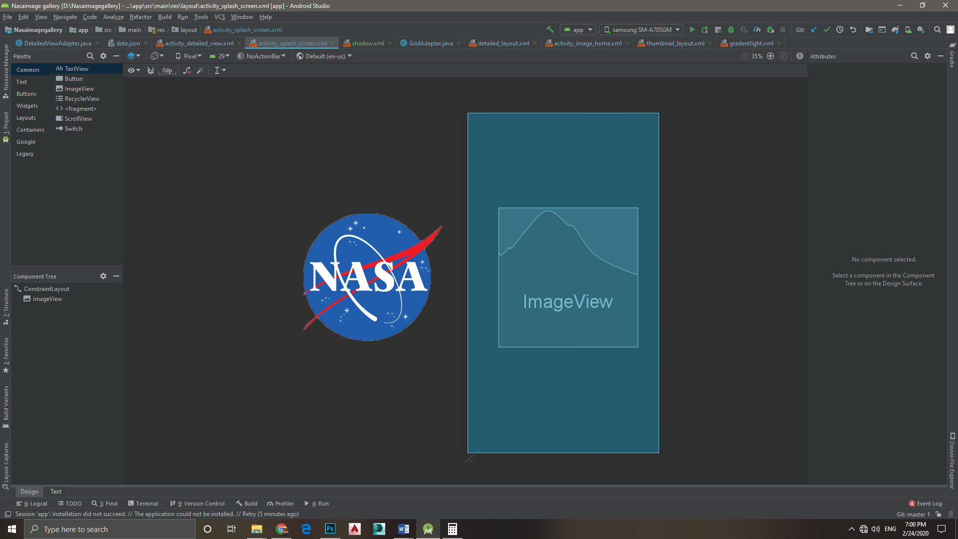

This is a simple welcome screen. User will stay for 5 seconds on this page . No functionality on this page

1. **Thumbnail layout**

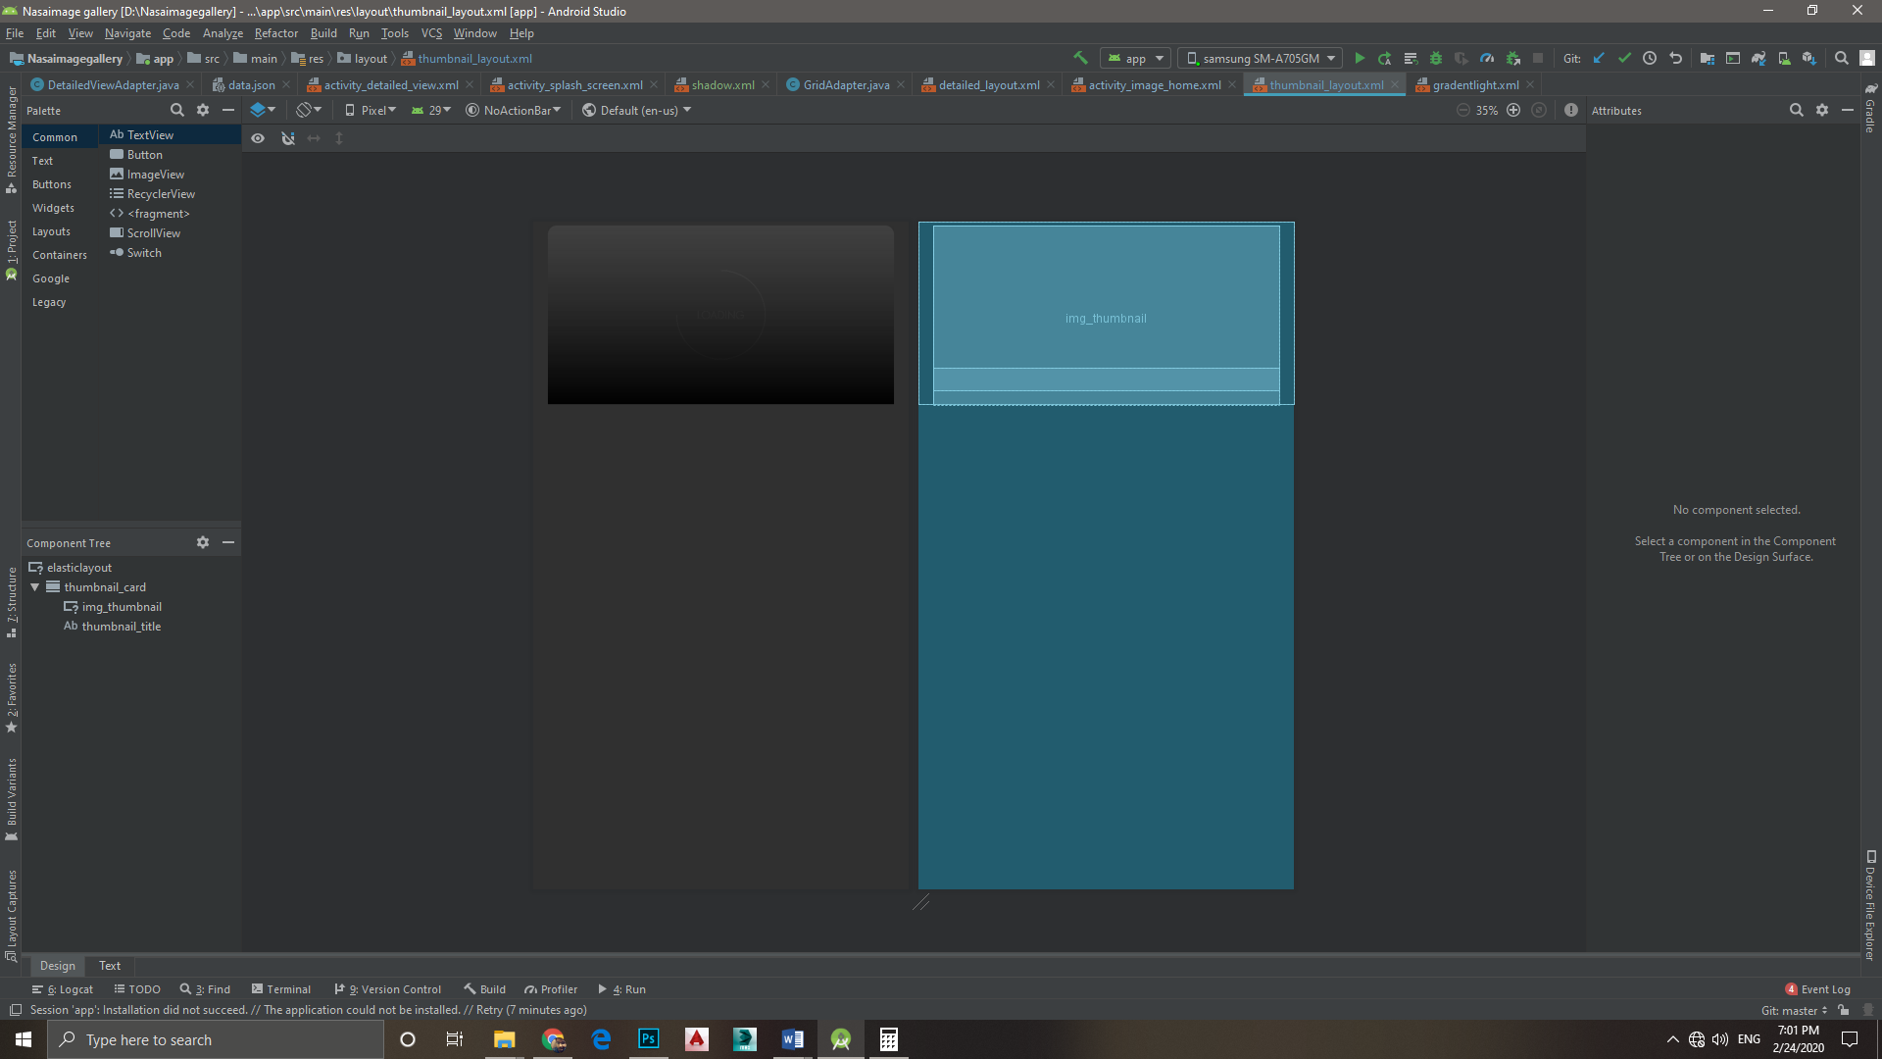

This is empty layout for thumbnails in the home screen.

This include ImageViewer for photo and TextArea for title

It has elastic animation for onClick events.

1. **Detailed Information Layout**

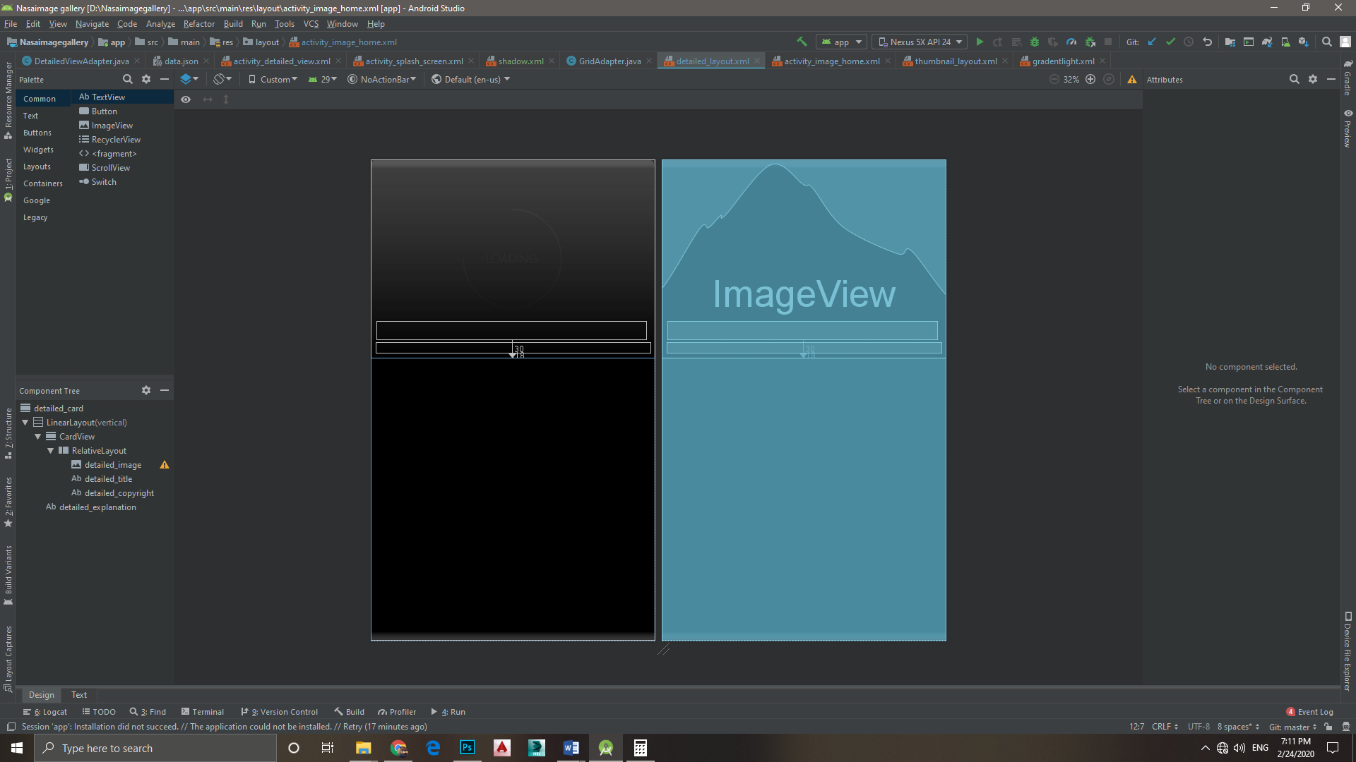

This is empty layout for the expanded details of the item.

It include ImageViewer for photo , 3 TextArea for title, explanation and copyright details , explanation textArea have inner scroll for scrolling through text.

**Project Structure:**

MVC structure is used for this project.

5 types of files are:

1. Activity Class
2. Adapter Class
3. Data handler class
4. View XML
5. Values XML

* Activity Class: This class deals with different types view properties and view Activity
* Adapter Class: This class is responsible for inflating items and populating data in them
* Data handler : this class fetch the JSON data from the .JSON file and convert it into Array List for different class to use
* View XML: This file provide basic layout for the screens
* Values XML : This files provide general values for the application

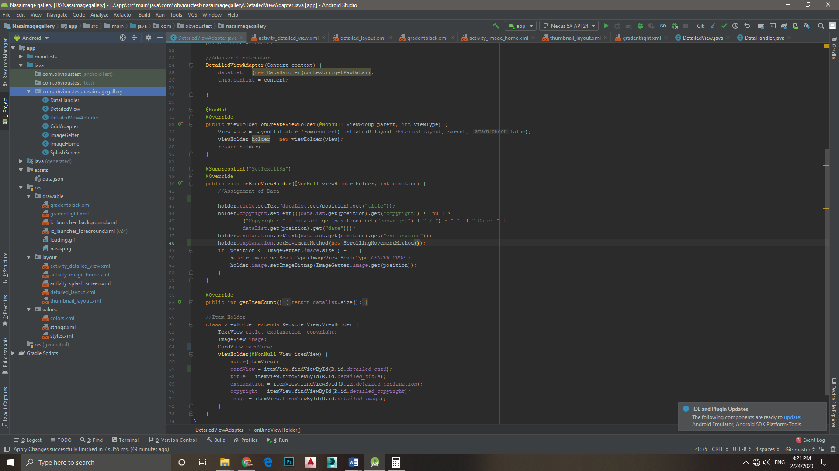

*photo of project structure

(Note: - More information about the Classes can be found in the comments of the class)

**Note:**

Application do not have action bar or any type of navigation because of a single flow and no additional features specified in requirement list.

**Further Development Scope:**

1. Bookmark feature
2. Share feature
3. Image saving
4. Search bar
5. Filter

And Many More